The POC for this guide is the 509th Communications Squadron Communication Focal Point
660-975-2666 / 687-2666
cfp@us.af.mil
SharePoint Guides can be Located Here
Whiteman SharePoint Home

***********REMINDER*************
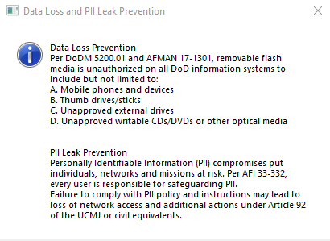

If you are using a government owned laptop, you have the ability to connect to the NIPRNet using a Virtual Private Network (VPN) connection. Through this connection you will have access to not only your government email, but also shared storage and most other resources that require a government system to access. If all you require is government email access and you are using a personally-owned computer (and a CAC reader), you can make use of Outlook Web Access (OWA). Either way, the government or personal owned computer must have a commercial Internet connection available. There are various other tools and options available. We’ll catalog them all here.

Table of Contents
- VPN Setup
- Mapping Network Drives
- Outlook Web Access (OWA)
- Global Video Services (GVS)
- Defense Collaboration Service (DCS)
- Secure Access File Exchange (SAFE)
- Microsoft Teams
- Desktop Anywhere
- OneDrive
- Skype for Conferencing
- Webex
- Intelink
- All Partner Access Program (APAN)
- Virtru
- Signal
- Zoom
- Slack
- GoToMeeting

- VPN (Virtual Private Network): Allows user access to Whiteman AFB networking, providing email as well as network functions.

- EURAM VPN (new). EURAM VPN capability is now deployed to over 200K AFNet laptops and laptop-like devices.

  - Ensure system is connected to your ISP (Internet Service Provider)

  - Insert CAC

  - Click the “USAF VPN Client” icon located on the desktop.

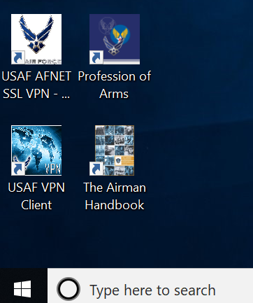

  - Click “Connect” on the next screen. It will automatically default to the Global USAF VPN server. As long as the banner states “Connecting to server…” it’s working.

    - NOTE: If connectivity is problematic switching servers may help improve your experience.

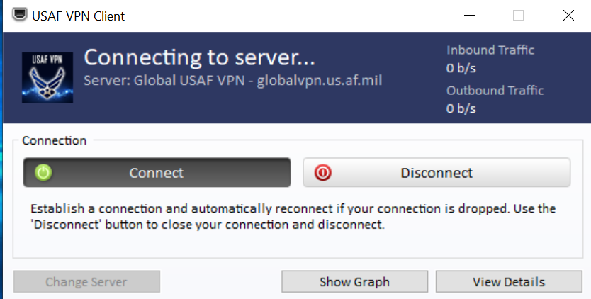

  - Click “OK, Proceed to Application” on the next screen.

    - NOTE: If connectivity is problematic switching servers may help improve your experience. (See Red Arrow above)

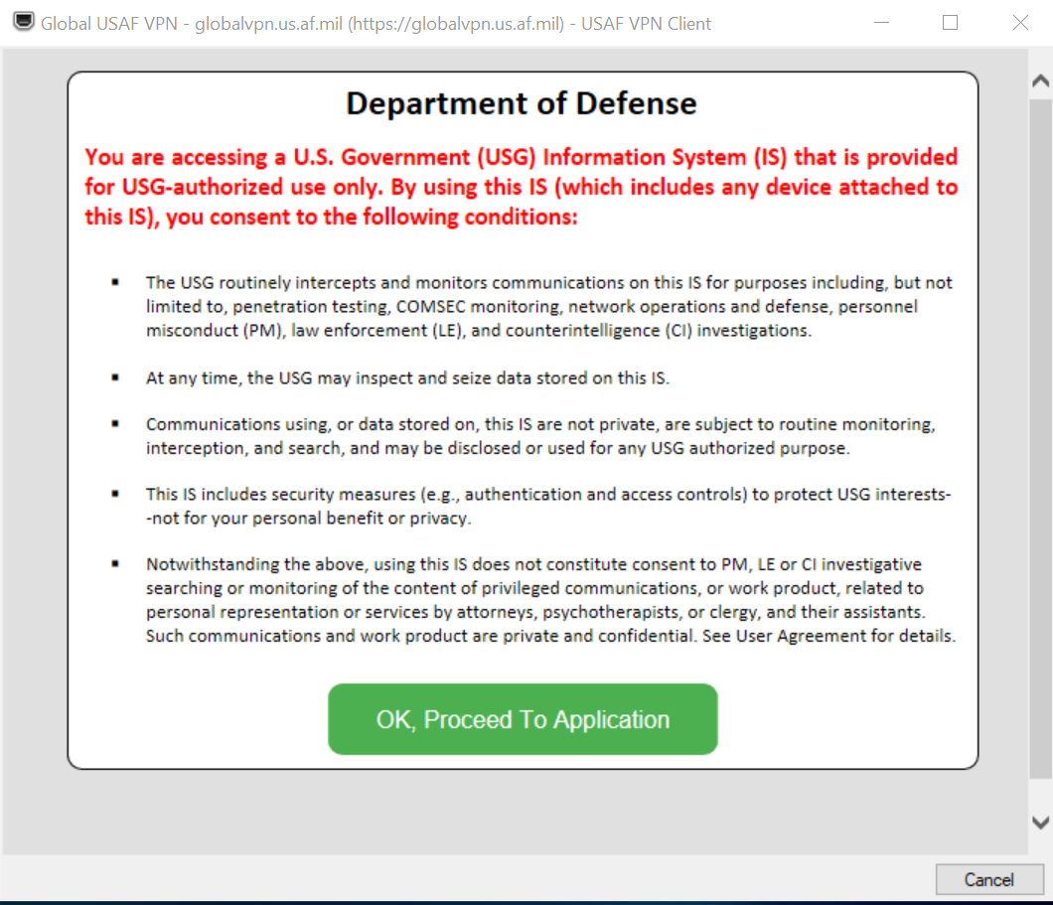

  - When the next screen comes up, click “More choices”. Select and click the “Authentication” certificate. (You may need to drag to box up with your mouse to see all the choices.)

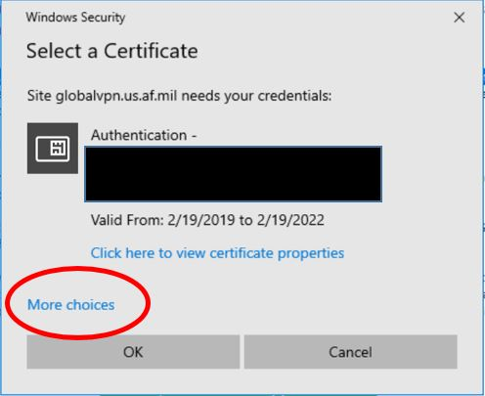

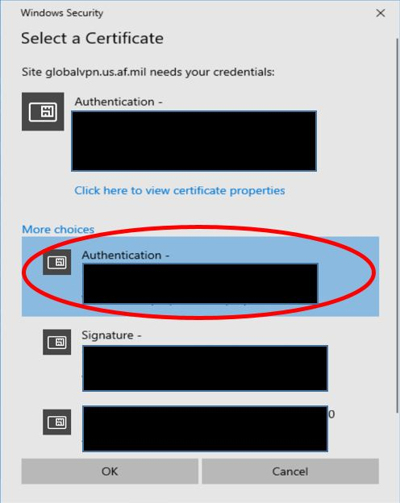

  - Click “OK”

  - The screen will say “Initializing…” (This may take a few minutes to appear), then go away when connected. You can validate your VPN connection by attempting to access your shared drives.

- Threat Management Gateway (TMG) (Legacy). “USAF AFNet SSL VPN” Client.

  - Assure laptop is configured to support wireless connectivity and connected to the internet.

  - Open 'AFNet VPN Client' or 'AFNet SSL VPN Client'

  - Click 'Connect' to establish VPN connection

  - If migrated, utilize the "Authentication Cert" (16-digit PIV-Auth certificate) from more choices, if not, continue to use 10-digit "ID Cert" to gain access

    - NOTE: If laptop users do not see the USAF VPN Client to their laptop, they are encouraged to go to control panel > configuration manager > actions > application deployment evaluation cycle > run now.

    - NOTE: ALWAYS remember to disconnect your VPN session when you are finished

- Mapping Network Drives:

- Click the Windows icon in the lower-left corner of your screen. Click “This PC”.

- Click on the “Computer” tab at the top of the window.

- Click “Map network drive”. Select “Map network drive”.

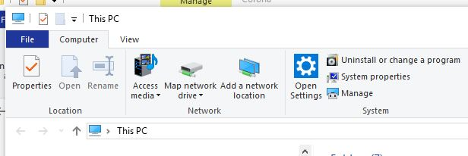

- Select a letter in “Drive”. Then in “Folder” type \\YWHG-FS-001V and select browse.

- Select the drop down arrow, until you find the desired folder you need to map to.

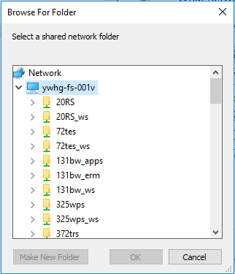

- Outlook Web Access (OWA): OWA can be accessed from a government owned, or personally-owned computer. With either system, it is highly recommended you use Edge or Chrome as your browser.

- Personally-owned computers: You will need to have a CAC reader with the appropriate software installed.

- To obtain/access CAC software, please use this link, https://www.my.af.mil/gcss-af/USAF/ep/contentView.do?contentType=EDITORIAL&contentId=c6925EC192DEA0FB5E044080020E329A9&channelPageId=s6925EC13419A0FB5E044080020E329A9&programId=t2D8EB9D63B957A7F013BB4A56B97073B

- Accessing OWA:

  - To access OWA using your home ISP connection, type:
    - https://owa.us.af.mil/

  - To access OWA when connected to the AFNET or VPN:
    - https://webmail.apps.mil/

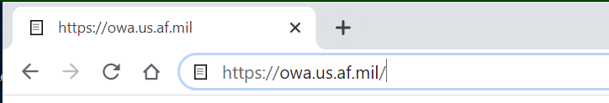

  - Select “Authentication” certificate

  - Click “OK”.

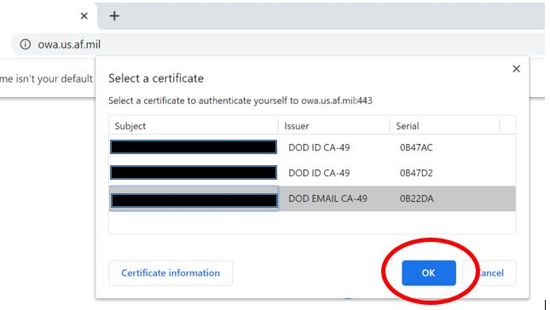

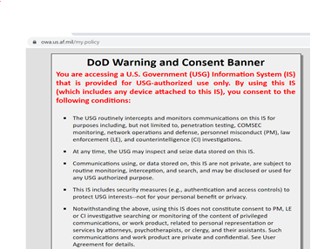

OK

  - Click “OK” when you receive the DOD Warning and Consent Banner.

  - The Outlook page will load up. Remember, you will not be able to access shared drives when using OWA. You will only be able to access shared drives when logged into VPN.

- Enabling S-MIME: S/MIME software is required to open encrypted email in OWA for both home and work computers.

  - When trying to open an encrypted email you will see this:

  - Click on “Click Here” to open the email in a new window.

  - You will be prompted to install S/MIME.

  - The following box below will pop up. “Click Run”.
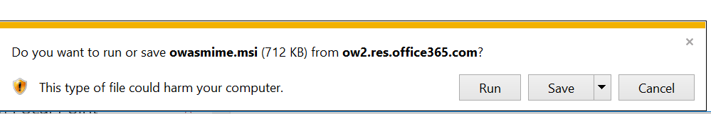

  - You will see the control run box, followed by the successful install of the control.

  - Close all browser pages.

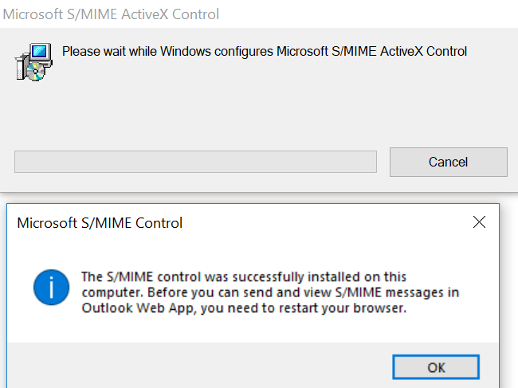

  - Once you open the OWA Link you will be receive the following message “Click Yes”.

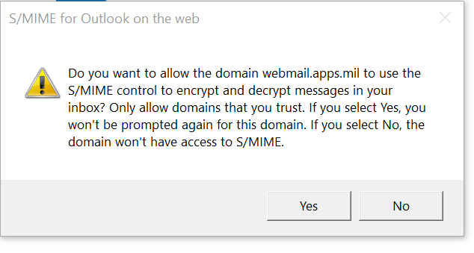

- Global Video Services (GVS)
- DISA’s modernized internet based video teleconferencing (VTC) service, GVS provides a full suite of on-demand, high-quality assured video conference capabilities for users to interact visually. GVS offers a desktop video solution, allowing face-to-face meetings from the desktop.

- Before use, GVS requires registration at: https://globalvideoservices.csd.disa.mil/gvs-web/

- To make calls/enter video teleconferences from your computer, you must have the CURRENT version of the GVS VidyoDesktop Client installed on your computer. The client can be located here once you’ve registered: https://globalvideoservices.csd.disa.mil/gvs-web/

- NOTE: Installation requires local administrative privileges.

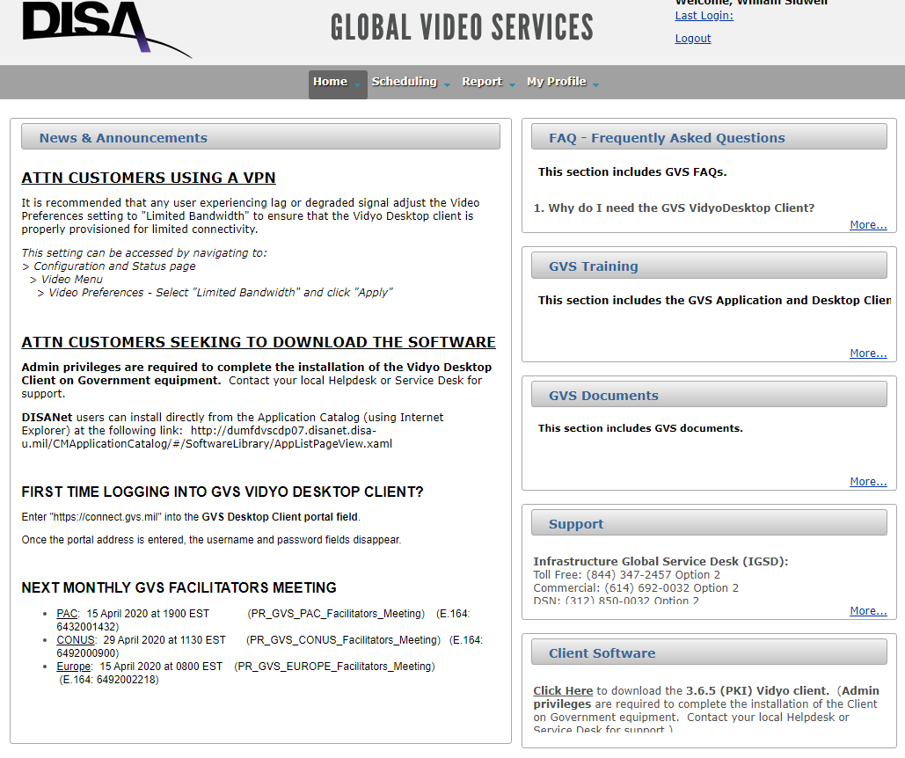

- Once the software is installed, the following steps are required the first time the VidyoDesktop software is launched (subsequent logins to the Client will require CAC selection):

  - Enter https://connect.gvs.mil into the “Portal” field. The username and password fields should disappear after the Portal address is entered.

  - Select “Log in”.

  - A pop-up window should appear prompting for your CAC certificate. Select and click “Log in”.

  - Select “Acknowledge” when prompted.

- Training videos for conference setup and operation can be located on the GVS website.

- Defense Collaboration Services (DCS)
- Accessing DCS (Defense Collaboration Services): DCS is an Interactive “Collaboration” tool for meetings up to 200 people in a desktop/laptop environment (not supported on mobile devices).

- To access DCS, please use the following link and be sure to select you PIV-Auth cert when prompted for your credentials (if you are given an error message close your browser and try again with a different cert): https://conference.apps.mil/

- Use the “Getting Started” tutorials situated on the right side of your browser window to learn about using the site.
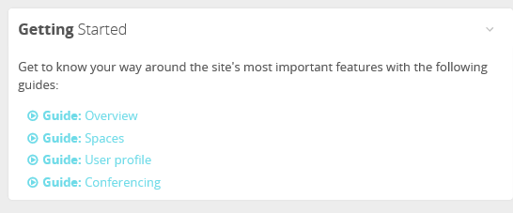

- Secure Access File Exchange (SAFE): A DoD service that allows you to exchange unclassified files up to 8.0 GB. This service is approved to transfer FOUO, Personally Identifiable Information (PII), and Protected Health Information (PHI) data. Files remain accessible for seven days.

- SAFE can be accessed here: https://safe.apps.mil/

- To send files to others select Drop-off

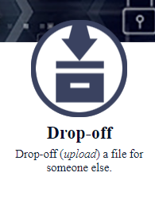
- Type in the email address(es) of all you’d like to make the file available to, selecting “Add” between addresses or “Add & Close” after adding the final address.

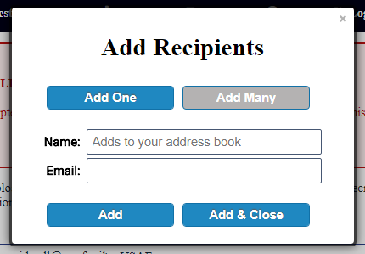

- Drag all files you’d like to share to the location identified on the web page.



- Ensure you check “Encrypt every file (REQUIRED FOR PII/PHI)” if you are uploading PII or PHI data. A passphrase will be required when encrypting files. The passphrase will not be stored or sent to your recipients. You must share the passphrase through other means.

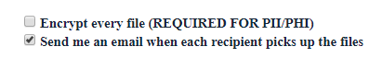
- Once you’re prepared click “Drop-off Files”.

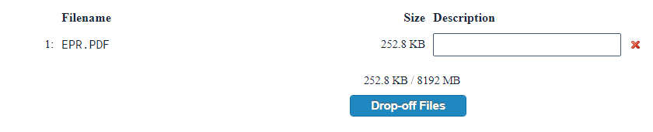

- An email will be sent to everyone you’ve addressed with instructions for file pick-up.

- A full user guide can be located here: https://dl.dod.cyber.mil/wp-content/uploads/dcs/pdf/unclass-DOD_SAFE_User_Guidev0_2d1.pdf

- Microsoft Teams: Microsoft Teams gives users a digital workspace, persistent chat, cloud file storage, online meetings and live document collaboration for every member of a created team. Customers often find the private group chat useful, as it allows them to collaborate with members sitting at different work stations, when connected to the AFNet and/or through VPN.

- Select Microsoft Teams from your windows start menu.
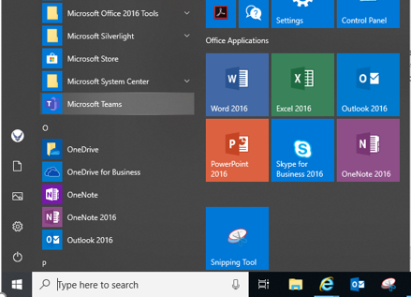

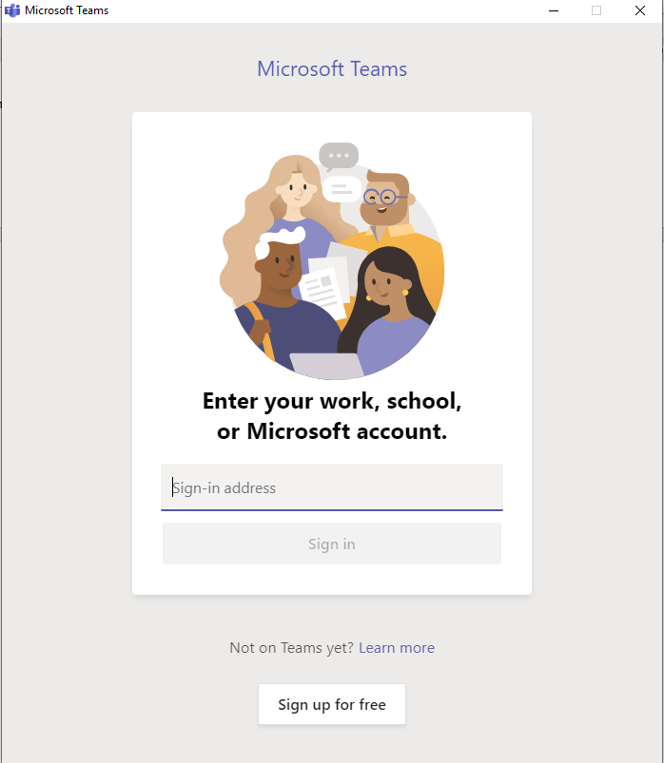
- Log in with email address (first.last@us.af.mil)

- For additional information, please consult the following link: https://usaf.dps.mil/teams/AFTeamsLaunch

- Creating a team
  - Select TEAMS in the navigation Bar
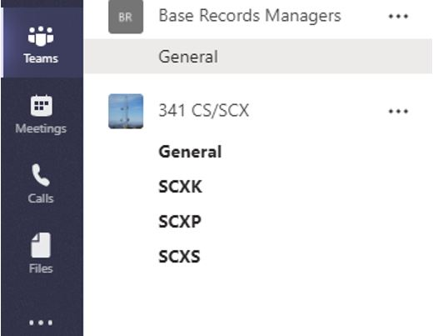


  - Select Join or Create a Team

  - After selecting “Join or create a Team”, the main area will populate with a new window as seen below.

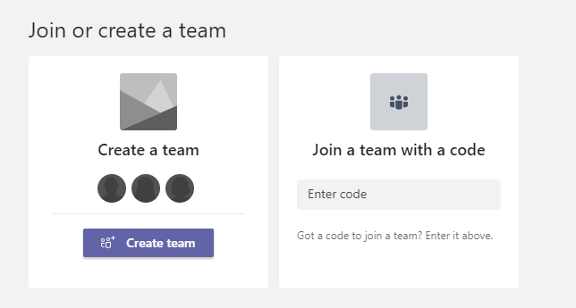
  - If you wish to create a new team select “Create a team”.

  - You will then be prompted to “Build a team from scratch” or “Create from an existing Office 365 Group or Team.

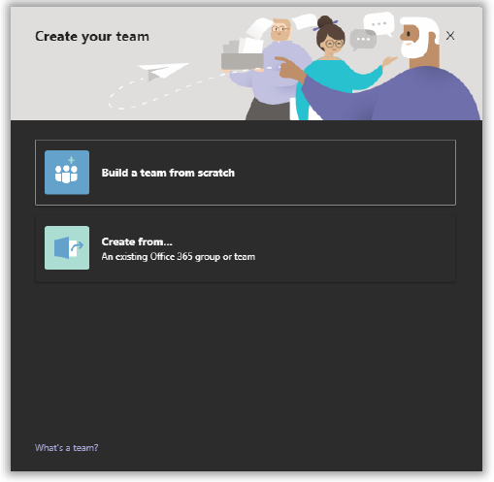

  - If you wish to build a team from scratch, the next step is to decide on what kind of team it will be in regards to search. Once you decide on your level of permissions, the next step is to give your team a name and a description (optional).

- Establishing Private and Public Teams:

  - 1. Private – People need permission to join

  - 2. Public – Anyone in the USAF can join

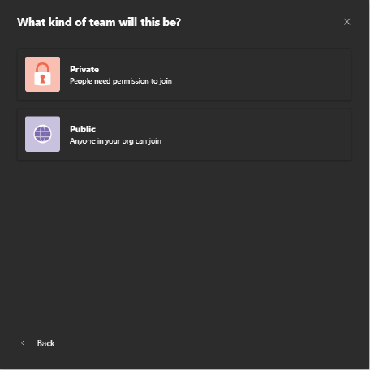

Note: It could take up to approximately 10 minutes for the team to fully provision (show up in your Teams list, General channel to appear/load).

  - The next step is to add members to your team. To add members now, type in the name of the user and select.

- Create from an existing Office 365 group or team:
  - Choose Team or Office 365 Group, depending upon your requirement.

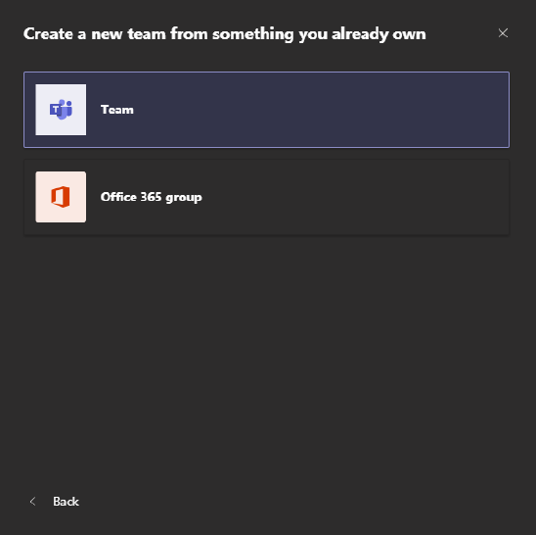

  - If you are creating a team from an existing team, you can choose from any team of which you are currently an owner or member. The existing team will not be changed.

- Desktop Anywhere: By installing the appropriate software utilities on a personal computer you can use a virtual PC to remotely connect to the Air Force network, providing the same capabilities of a government laptop with a VPN connection. Requires a CAC reader, personal computer and commercial internet connection.

- Setting up Desktop Anywhere on your personal computer is more involved than most of these methods. Required software, installation guides, support and frequently asked questions visit this AF Portal page or log into the AF Portal and search “Desktop Anywhere”.

- OneDrive: Online file storage.
- Desktop Client
  - Upon first sign on navigate to the Start Menu and type “OneDrive”
  - Select the “OneDrive” desktop app
  - Sign into OneDrive with your USAF email address
  - Adding Files and Folders
    - You’ll be prompted whether or not you’d like to add some common folder locations to OneDrive
    - You can add or delete files from your OneDrive folder the same way you would for any other folder in the File Explorer. These changes will sync to the cloud automatically.
  - Share Files and Folders
    - Right-Click on a file or folder within the OneDrive folder
    - Select Share, then enter the names or USAF emails of the individuals who you wish to share with
  - Files on Demand
    - Right click on the OneDrive file or folder
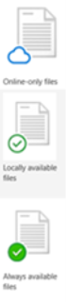
    - Select ‘Free Up Space’ to convert to cloud-only storage (not accessible without internet)

    - Select ‘Always Keep on This Device’ to make sure a local copy is always available.
- Web Client
  - Navigate to: https://usaf-my.dps.mil
  - Sign into your work account with your USAF email
  - Create and Delete Files and Folders
    - Select New and choose the type of file you want

    - To rename the file, click the file name in the title bar, for example ‘Document’, and then type a name.
  - Share Files and Folders
    - Select a file or folder, right click on it, and select ‘Share’
    - Enter the names or USAF emails of the individuals you wish to share with and select ‘Send’
  - Manage Files on Demand
    - Select Sync
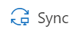
    - Enter your USAF email if prompted

- Skype for Conferencing: In addition to traditional calls and messaging services, Skype can be used for conference calling.
- From the Skype for Business home screen, select the Groups tile, other contacts, and lightly swipe downwards or right-click each contact you want in the conference call.
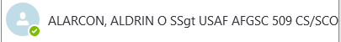
- Right click your contact and Select Call from the app commands that display automatically.
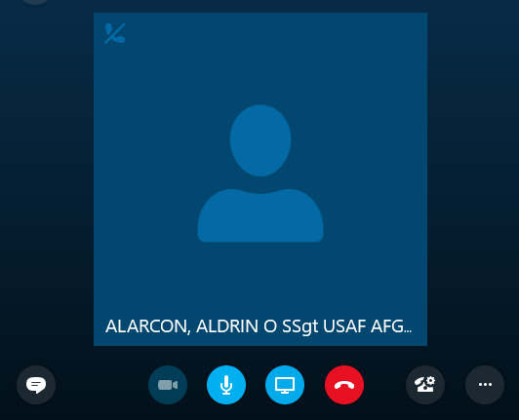
- Your invitation will display on your contacts’ devices and they’ll join the call after they accept the invitation.

- Once your invitation has been accepted, there will be a + symbol at the top right which will be used to add more participants.
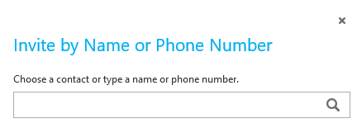
- If you want to add more participants:
  - Swipe in from the bottom of the call window or right-click with a mouse, and select Participants.
  - Select Invite more people, and type the name or phone number of the contact you want to invite.
  - From the search results, select the name or phone number you want, and select the plus sign (+).
  - If you selected a name, an invitation is sent to the contact. The contact joins the call after accepting the invitation. If you selected a phone number, the conference will dial the contact at that phone number.
  - The call window displays the mic button to mute/unmute yourself and the handset button to end the conference call. To access other commands during the call, swipe in from the bottom of the call window or right-click with a mouse, and then do the following.

- Webex: Free web-based video conferencing service, run by CISCO. For use on personal computers.

- Establishing a session requires that you create an account, but those you invite to a conference can attend without creating a login. You can access the service here: https://www.webex.com/

NOTE: The site currently dealing with heavy demand and they state that “there may be cases where our free users degraded services”.

- Intelink: Offers various web applications. There are many applications, but some useful collaboration tools include Inteldocs, (file sharing and storage) and Messenger (group chat). A CAC reader is required.

- Navigate to https://www.intelink.gov/ to access the site. Log in with your CAC.

- To view all applications, click the “Intelink Applications” link on the main page.

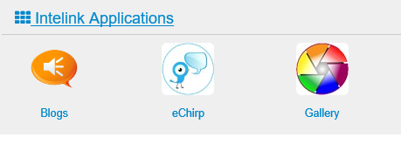
- Messenger

  - NOTE: Detailed instructions can be located here: https://intellipedia.intelink.gov/wiki/IIM_WebClient

  - Create an Ad-hoc Room (room will only exist as long as there are users in it)

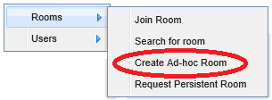
    - Click the Rooms menu

    - Select Create a room from the drop-down

    - Enter the room information in the Create Room dialog. Setting a password will prevent access to anyone who has not been provided the password.

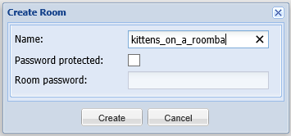

    - Click the Create button when finished. The room will now appear in search results.

    - Provide the Room name and password (if set) to any you’d like to have join.

  - Joining a Room

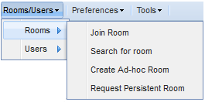
    - Join Room allows a user to join a room.

      - To join a room, a user must know its name.

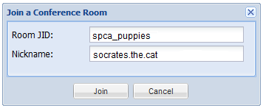

      - In the image above, the room is spca_puppies. The field below that shows the user’s nickname as it will appear when they’re in that room.

    - Search for Room allows a user to search for a room.

      - Click the Rooms Menu from the toolbar

      - Select the Search for room menu option

      - Enter a room name or partial name and click the Search button

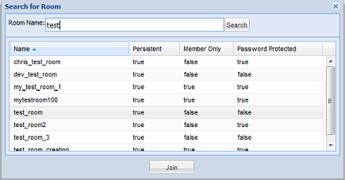

      - Click the Join button to enter the room

- Inteldocs

  - NOTE: Detailed instructions can be located here: https://intellipedia.intelink.gov/wiki/Inteldocs_User_Manual

  - Creating a new Folder

    - Clicking on the Folder/Plus icon enables you to create a new sub-folder within your current location. The Create a New Folder form will prompt you for the following fields:

      - Folder Name
      - Title
      - Tags
      - Select Default Sharing Level
        - Inherit – Inherit permissions from the current folder.
        - Private – Only accessible by you. Select this option if you want to share the folder with specific people later.
        - Public – Read permission granted to everyone.
    - Click Save to create the folder

  - Uploading a File

    - Click the Upload icon to upload new file(s) into the current folder. You can upload up to 100 files at once.

    - Providing the name of a file in a public folder will allow others to Search for it

  - Searching for a file or folder

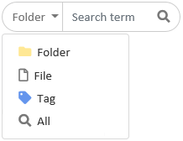

    - The Search box located on the top right hand side of the page allows you to search for files, folders, tags or all three. It will only display items that you have access to, regardless of their location.

  - Using Group folders

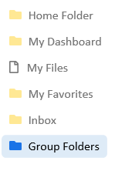
    - The Group folders page allows you to create a new root level folder to be used by a group/organization. Group folders require a minimum of 2 administrators.

    - Searching for a group folder will allow you to determine if the group folder you are looking for already exists.



    - If you find the folder you’re looking for you can either

      - Click the name of the folder to gain access if the folder is public or you’ve been granted access:

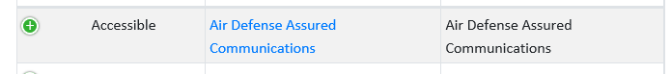

      - Or, click Request Access to inform the folder administrators that you require access:

    - If you cannot find the folder you’re looking for and would like to create a new one, click the link located above the search bar.

      - You will be brought to the Create New Group Folder page and prompted to provide the following:

        - Folder Name
        - Title
        - Tags

        - You will also be required to identify an additional administrator before clicking Save and creating the folder

13. All Partner Access Network (APAN)
- APAN is a collaboration tool to provide a virtual community to connect with your team members. Unfortunately, due to the heavy demand of many users trying to reach out to APAN, the site requires all users to open up a support ticket to get in touch with their customer support service. This is required before even creating a virtual meeting. To reach to the APAN customer support to begin a session, email https://community.apan.org/support/p/contact to create a support ticket.
https://www.apan.org/
14. Virtru
- Virtru is able to provide encryption for emails and provide S/MIME configuration for Gmail, Google Drive, and Microsoft Email. However, to get started with the process, it requires users to send their information to customer service (name, company, email, and reason for using). From there an email will be sent to the user notifying them that a sales team will reach out and schedule a time to conduct a demo first.
https://www.virtru.com
15. Signal
- Signal is inaccessible on a government computer, however, it can be reached via personal computer. Below is the link to the how-to guide:
https://support.signal.org/hc/en-us/categories/360000674771-Getting-Started
16. Zoom
- Zoom provides HD video, audio, collaboration, and chat. Zoom is inaccessible on a government computer, however, it can be reached via personal computer.

- To get started, follow the below link:
https://zoom.us/

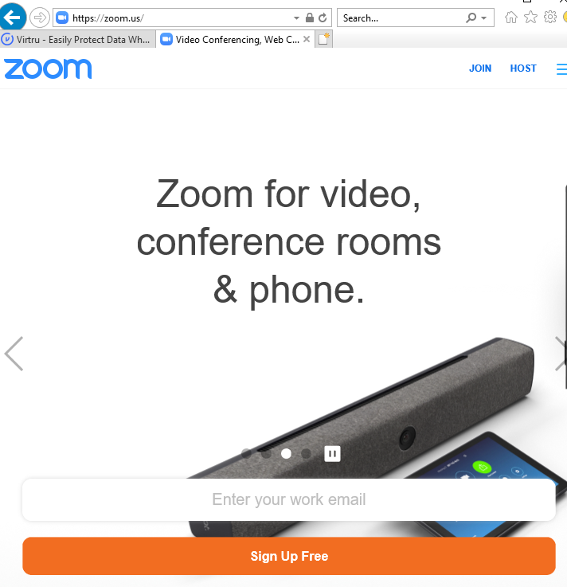
- You will be required to sign up and create an account.

- A window will appear where you will have to confirm your email, press “Confirm”.
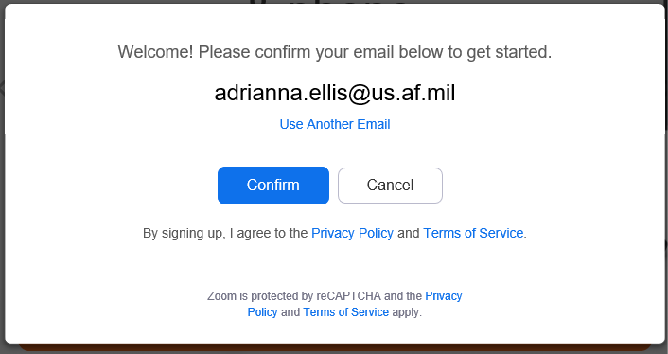

- You will then be prompted to click “Activate Account”.
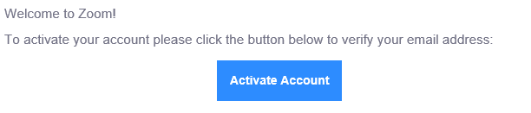

- You will be brought to a screen to enter your account info.
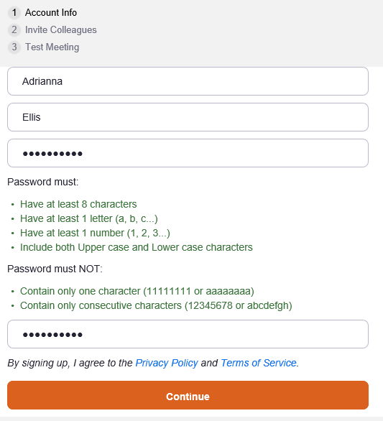

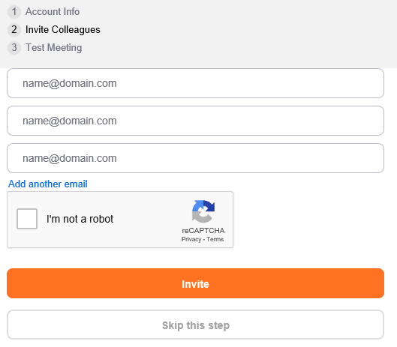
- It is not required that you invite colleagues, you may click “Skip this step”.

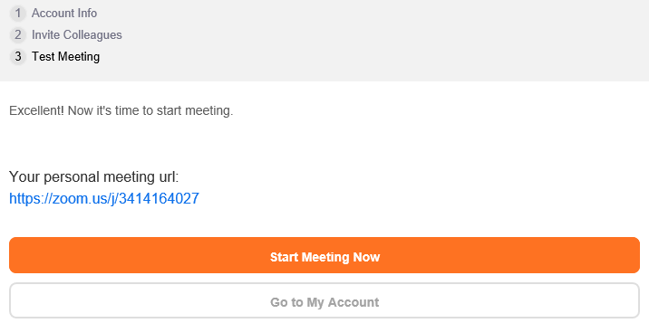
- On the last step, you may start your meeting. You will also be given a meeting URL that you can share.

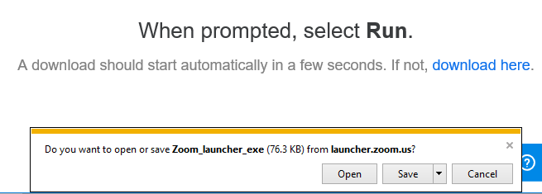
- Lastly, an .exe will appear on the bottom of your screen prompting you to run. Click “Open”, and if that doesn’t work, try the blue text “download here”. From there your session will begin. If you are receiving network connectivity issue on your government device, please try your personal computer.

17. Slack
- Slack is available as a virtual chatroom:
https://slack.com
- To get started, users will need to create an account by clicking “Get Started”.
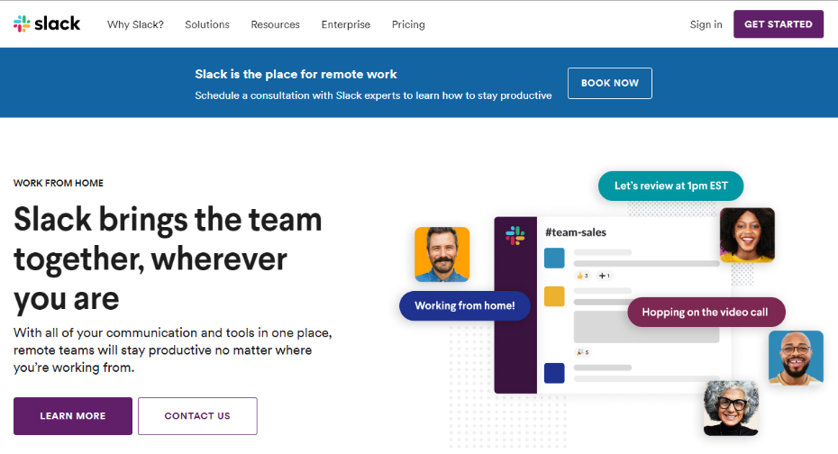

- When you register you will enter in your email address. From there a code will be sent to your email to validate. Enter the code.
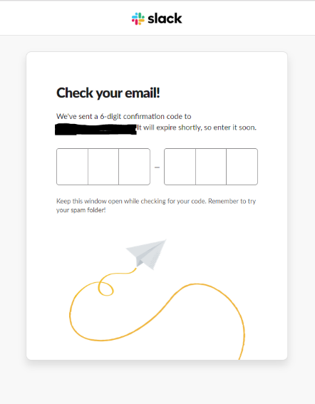

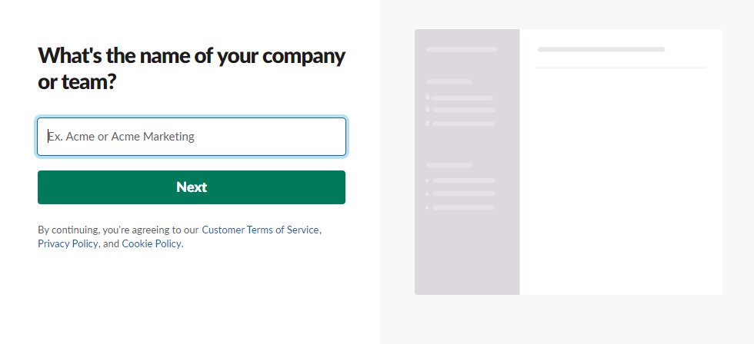
- Once validation goes through, you will be brought here to begin your chat session. Begin by entering your company/team name and click “Next”.

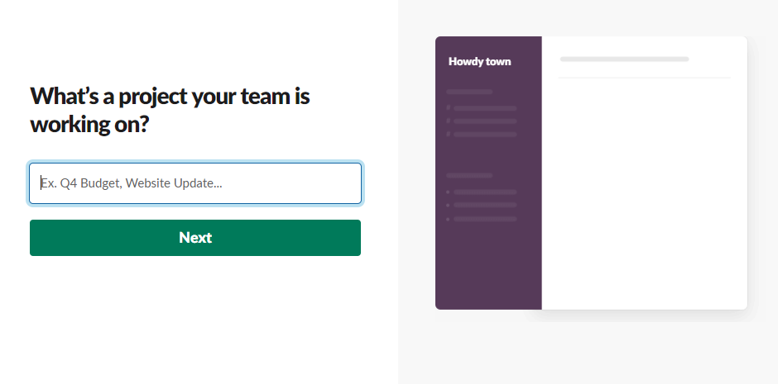
- From there, users will be prompted to put a name to their project (name of their chat room)

- You will be given an option to invite colleagues, but you may click “skip for now”.
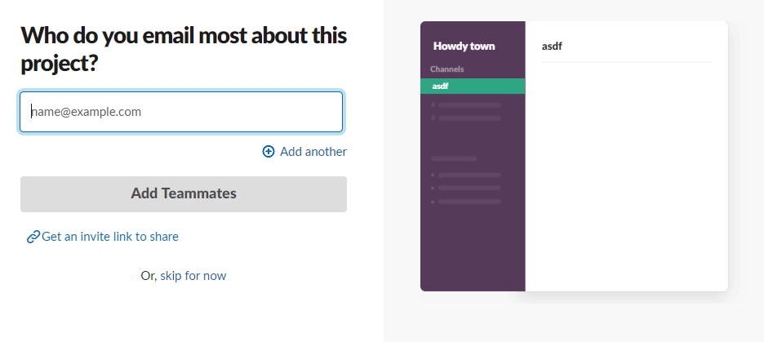

- Review your chat, and when done click “Finish Setup”.

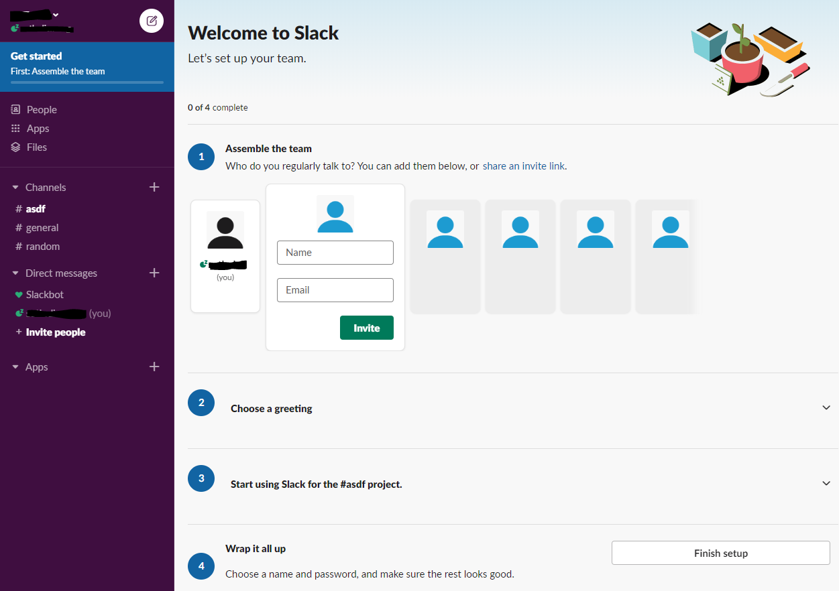

- Users will be sent an email with the link containing the URL to their chat room to share.
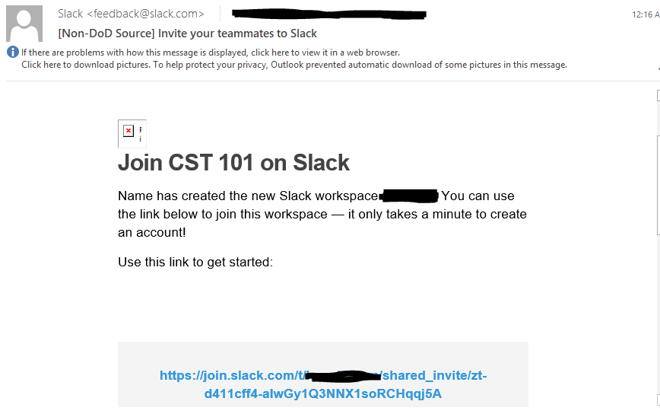

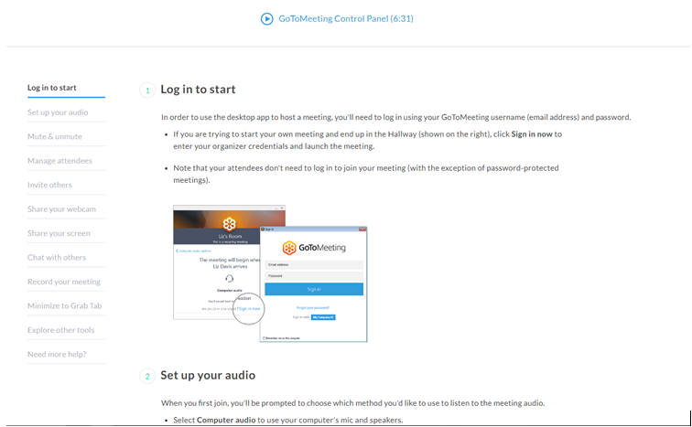
18. GoToMeeting
- GoToMeeting is a Teleconferencing application made by LogMeIn, which enables quick and easy group voice & video meetings. Two guides are available in the following links and will appear as the picture below. These guides walk users through initial setup and establishing a meeting https://support.goto.com/meeting/organizer-user-guide

